Guide on Online Fee Payment.

Step 1 : Registration
- All parents are required to complete a One Time Registration by accessing the link https://epay.federalbank.co.in/easypayments/
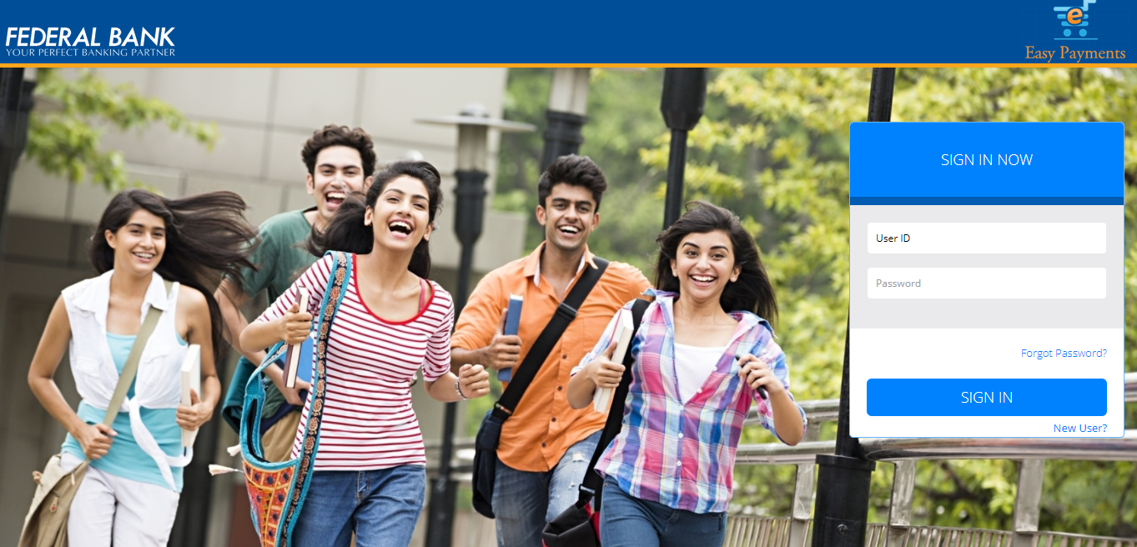
- Click on the New User option, automatically you will be redirected to the below page
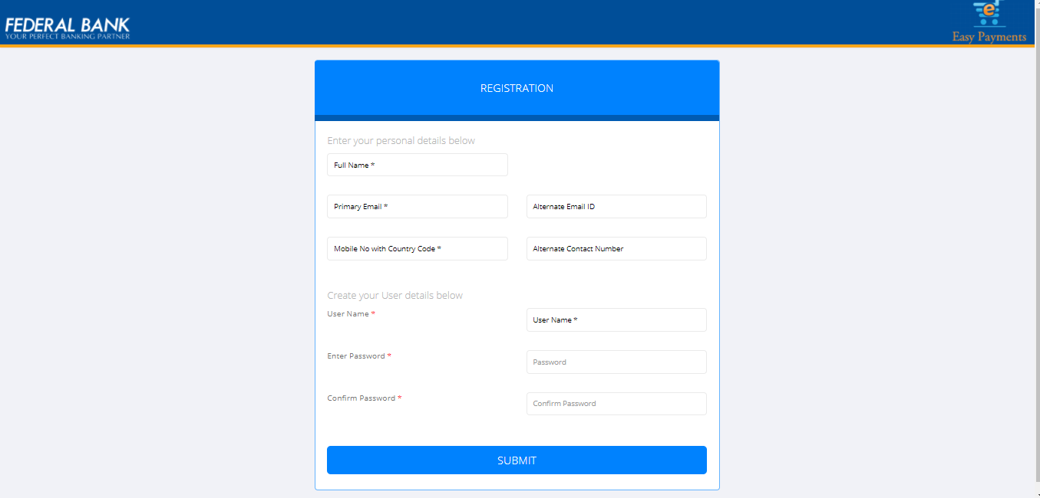

- Key in all the mandatory data and proceed by clicking the submit button.
- You will be redirected to a new window which will prompt for an OTP which would have been automatically generated and sent to the email id mentioned in the previous screen
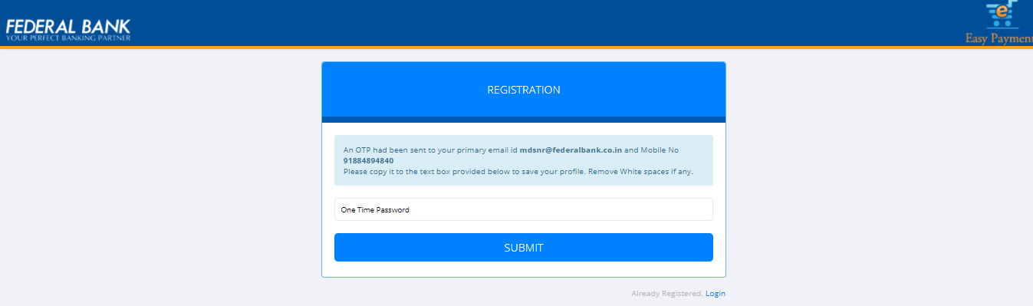
- Please fill in the OTP and proceed by clicking the Submit Button
- The below confirmation will be displayed upon successful user creation
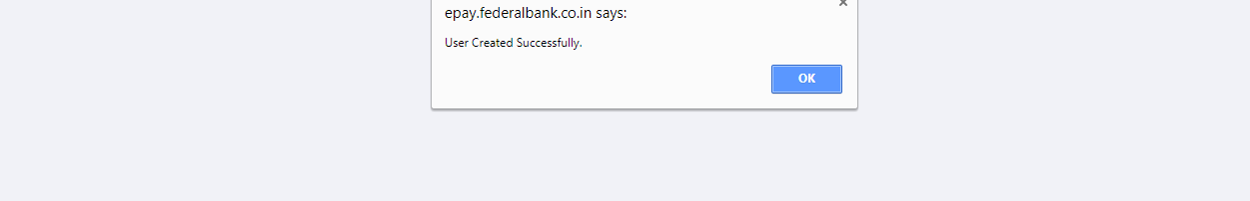
- After Clicking the OK button you will be automatically redirected back to the Login Page.

Step 2 : Login
- Kindly provide your User ID and Password created at the Time of Registration and Click the submit button
- You will now be redirect to the fee payment portal
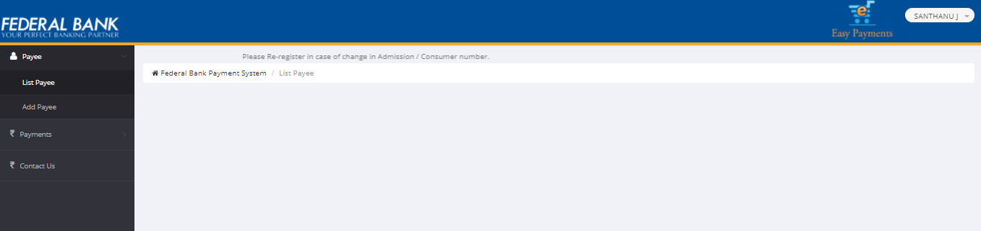
- Please proceed by Clicking the Add Payee Option. Now Select the Category as School,Payee as Christwood School (CDSL) and Consumer Number which is your child’s Student ID and click Continue
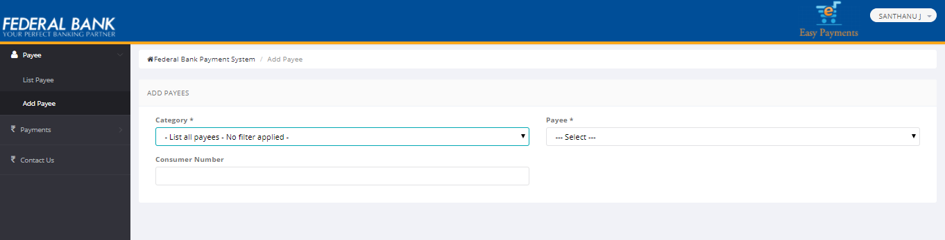
- Now please check your details and click on the Confirm Button
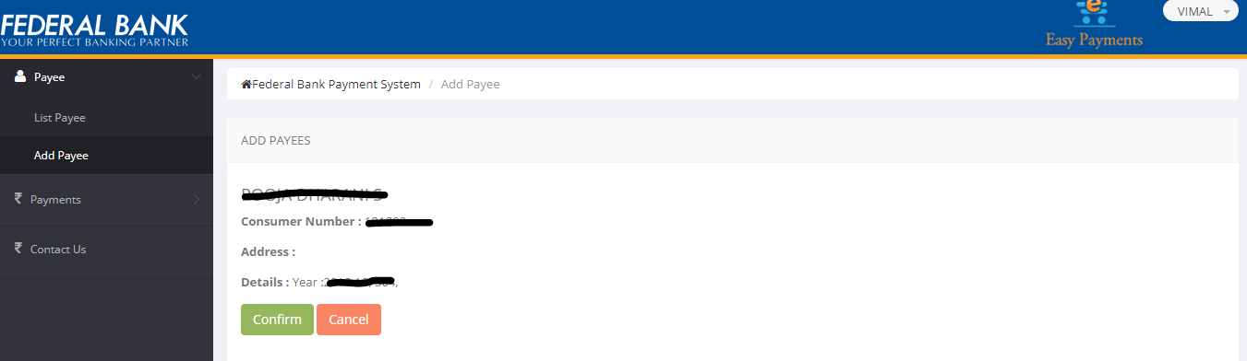
*Note – A Parent can add more than one child under the same login using the Add Payee option.

Step 3 : Payment
- To make the payment, please click on the proceed button

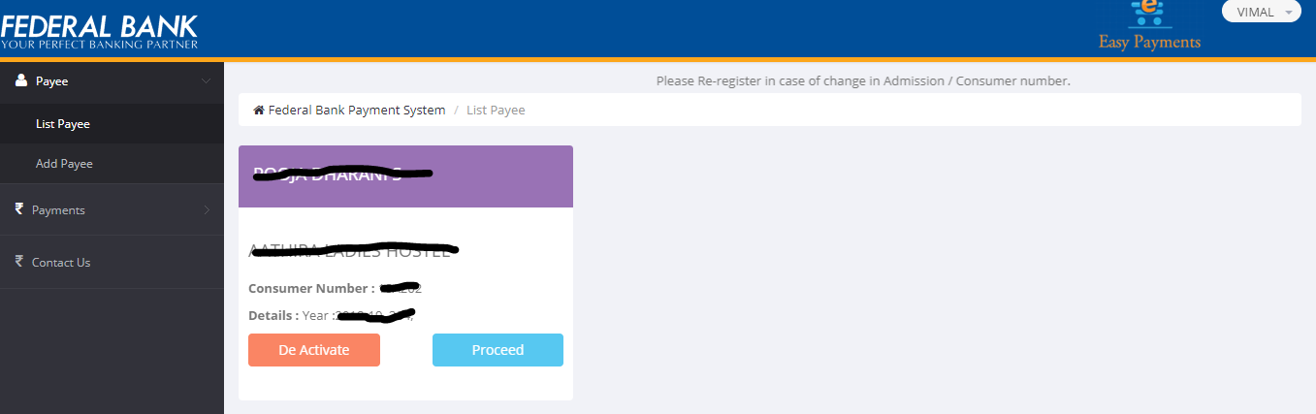
- Select the fees to be paid and Click the Pay bill option
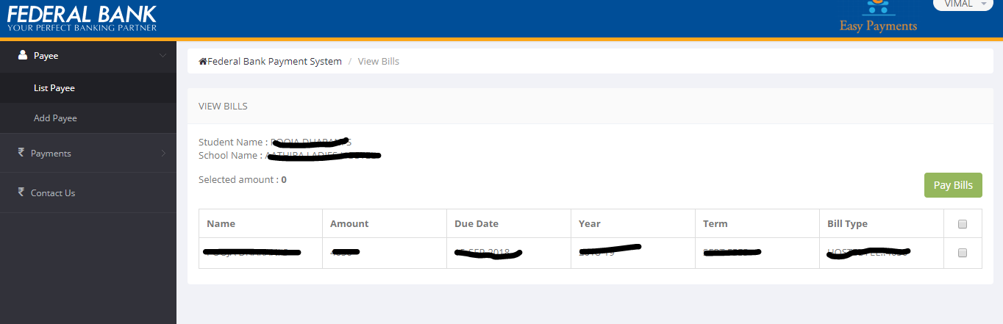
- Please check the amount to be paid and also make note of the Reference number and Click Proceed to Pay
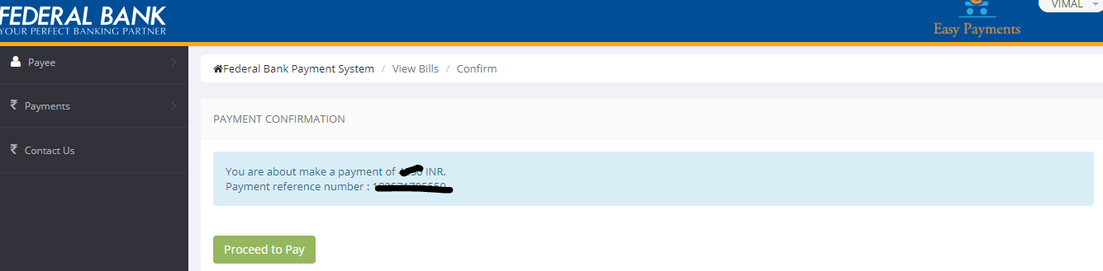

- You will be redirected to Federal Bank Payment Gateway. Select the desired mode of Payment and Click on Continue and complete the Payment.

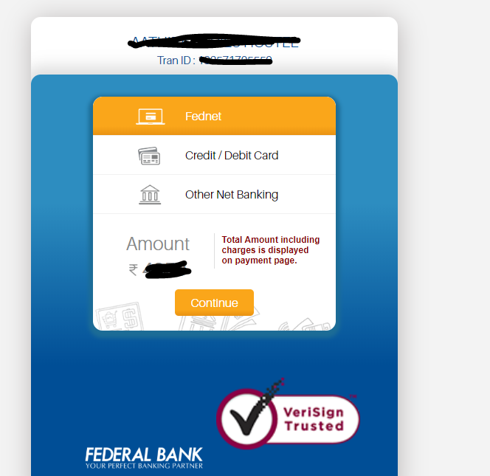

- After the Payment has been successfully made, the receipt can be downloaded or printed

Thank You

